Test Case: tc006_SPX_Dev5_Crear_Requisicion_Spot_Tipo_Cobro_Proyect_Urgent
Step 1 - Enter username and password and click to button Enter: Credentials Entered
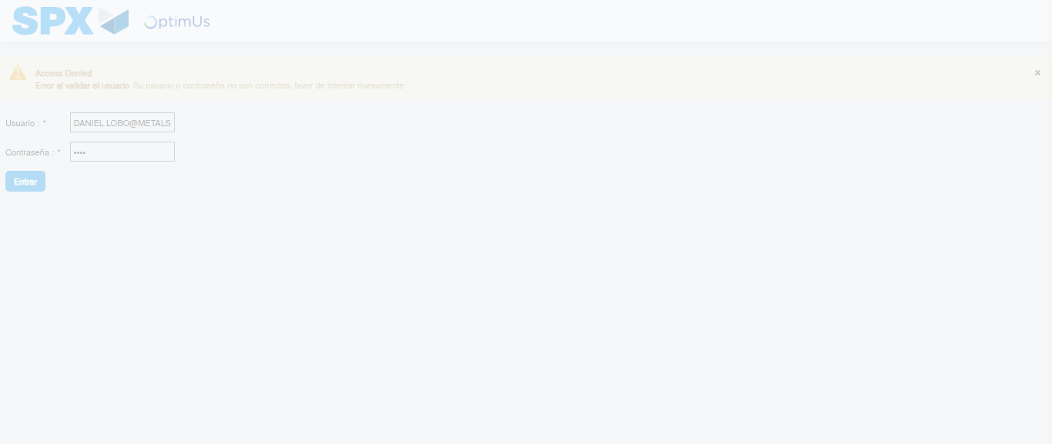Image file-name: QC_Testing-tc006_SPX_Dev5_Crear_Requisicion_Spot_Tipo_Cobro_Proyect_Urgent-1784214571490

Step 2 - Select to UEN and Access to Spot Buy Requisitions : UEN Correctly selected and Correct access
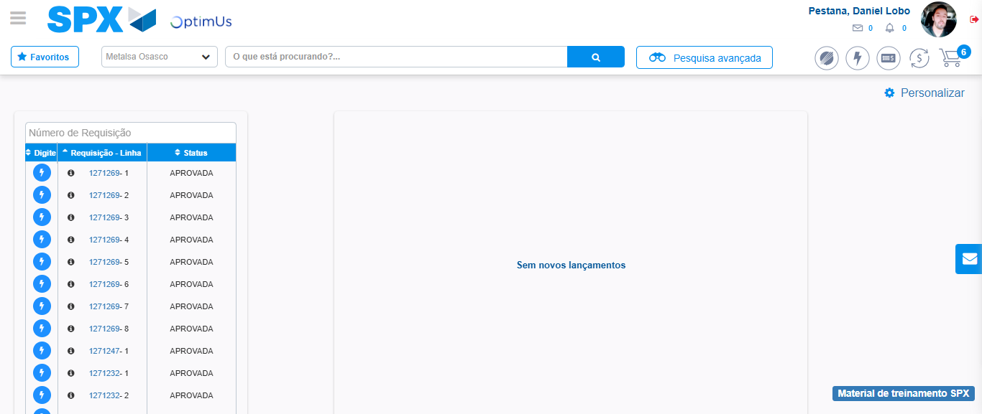Image file-name: QC_Testing-tc006_SPX_Dev5_Crear_Requisicion_Spot_Tipo_Cobro_Proyect_Urgent-1784214597463

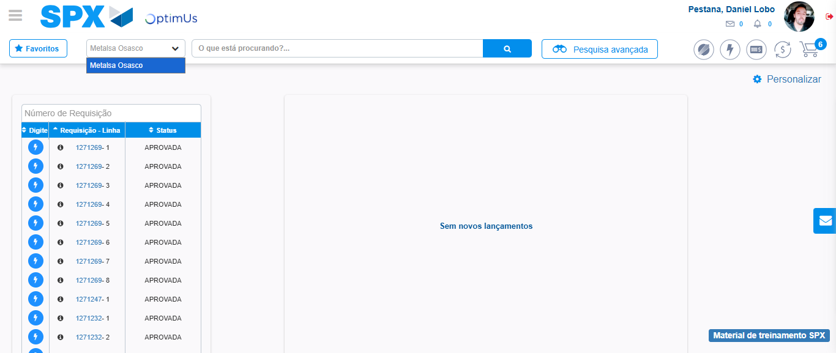Image file-name: QC_Testing-tc006_SPX_Dev5_Crear_Requisicion_Spot_Tipo_Cobro_Proyect_Urgent-1784214600068

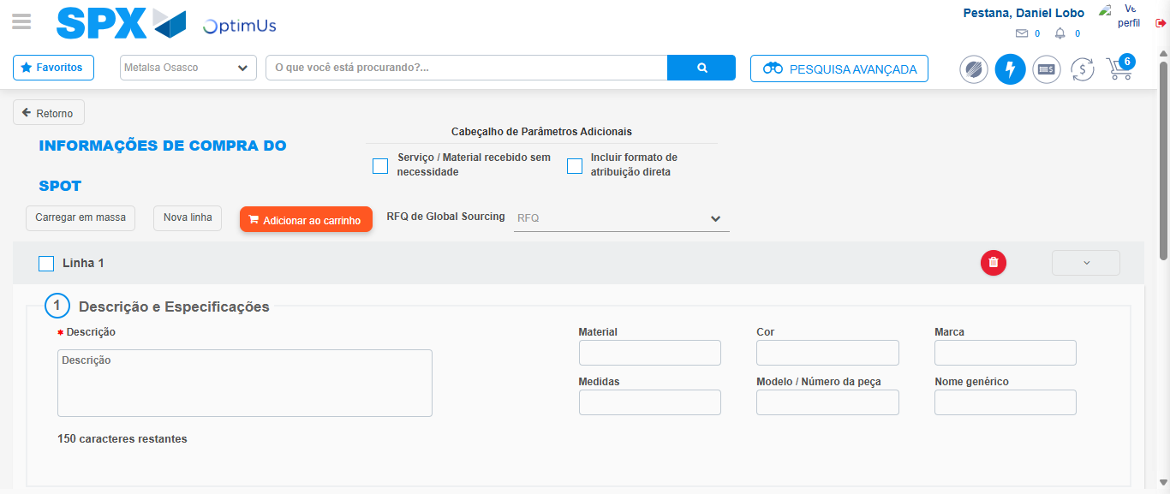Image file-name: QC_Testing-tc006_SPX_Dev5_Crear_Requisicion_Spot_Tipo_Cobro_Proyect_Urgent-1784214622093

Step 3 - Data Capture Spot Buy Requisition: Data captured correctly
Image file-name: QC_Testing-tc006_SPX_Dev5_Crear_Requisicion_Spot_Tipo_Cobro_Proyect_Urgent-1784214622290

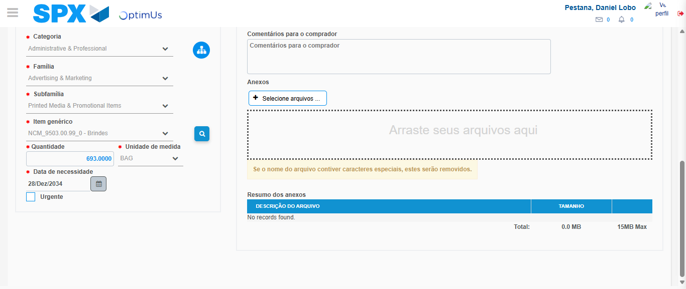Image file-name: QC_Testing-tc006_SPX_Dev5_Crear_Requisicion_Spot_Tipo_Cobro_Proyect_Urgent-1784214634922

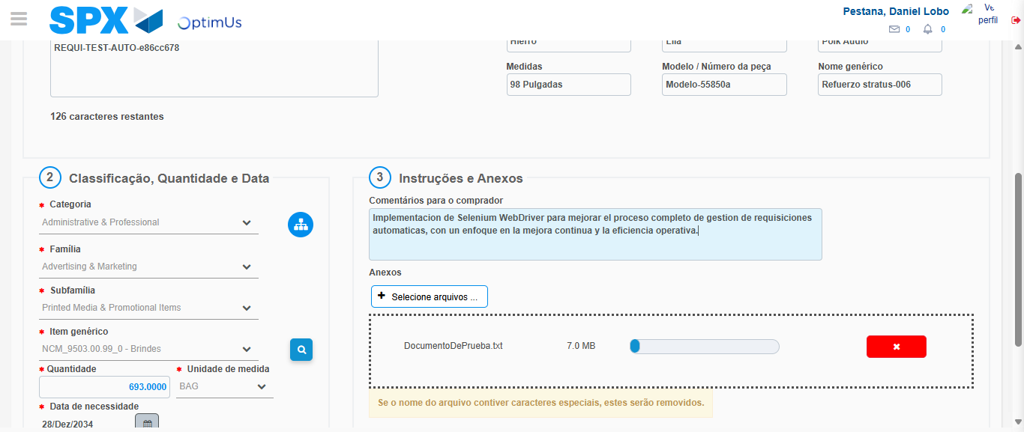Image file-name: QC_Testing-tc006_SPX_Dev5_Crear_Requisicion_Spot_Tipo_Cobro_Proyect_Urgent-1784214635696

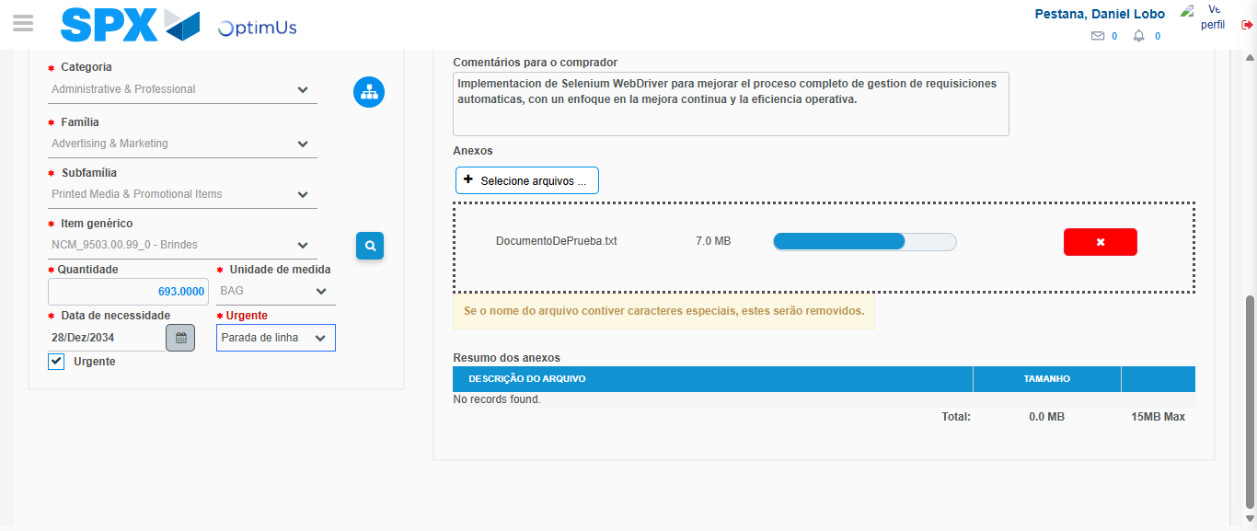Image file-name: QC_Testing-tc006_SPX_Dev5_Crear_Requisicion_Spot_Tipo_Cobro_Proyect_Urgent-1784214640511

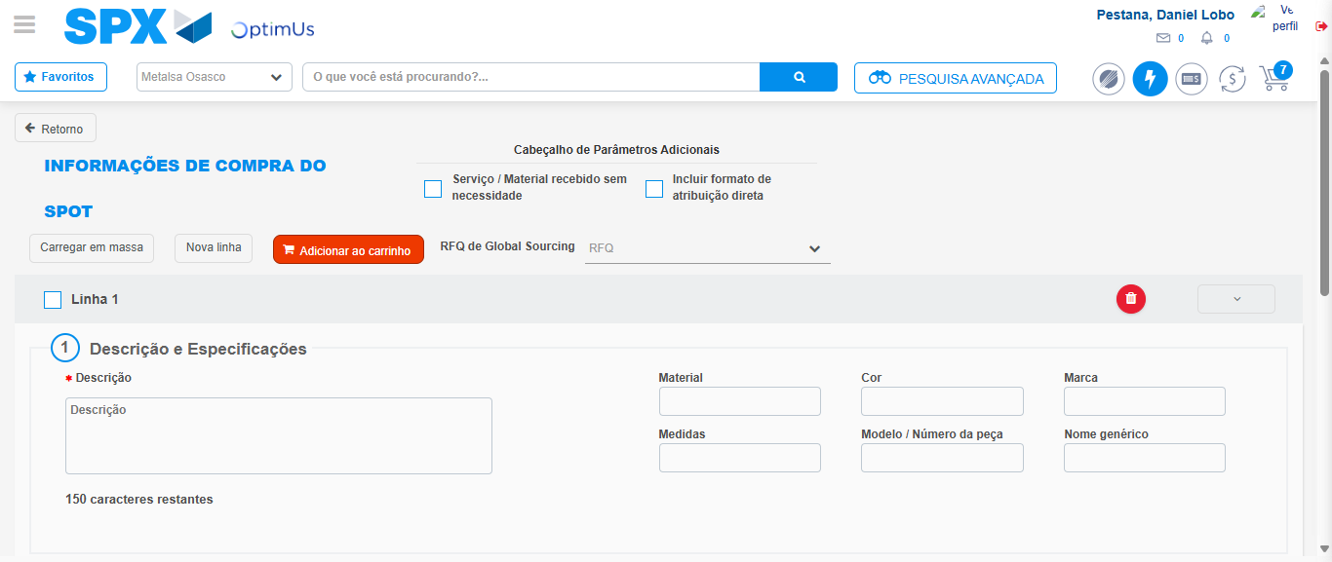Image file-name: QC_Testing-tc006_SPX_Dev5_Crear_Requisicion_Spot_Tipo_Cobro_Proyect_Urgent-1784214647942

Step 7 - Return to Main Page SPX : Return to Main Page SPX
Image file-name: QC_Testing-tc006_SPX_Dev5_Crear_Requisicion_Spot_Tipo_Cobro_Proyect_Urgent-1784214597463

Image file-name: QC_Testing-tc006_SPX_Dev5_Crear_Requisicion_Spot_Tipo_Cobro_Proyect_Urgent-1784214600068

Image file-name: QC_Testing-tc006_SPX_Dev5_Crear_Requisicion_Spot_Tipo_Cobro_Proyect_Urgent-1784214622093

Image file-name: QC_Testing-tc006_SPX_Dev5_Crear_Requisicion_Spot_Tipo_Cobro_Proyect_Urgent-1784214650273

Image file-name: QC_Testing-tc006_SPX_Dev5_Crear_Requisicion_Spot_Tipo_Cobro_Proyect_Urgent-1784214650464

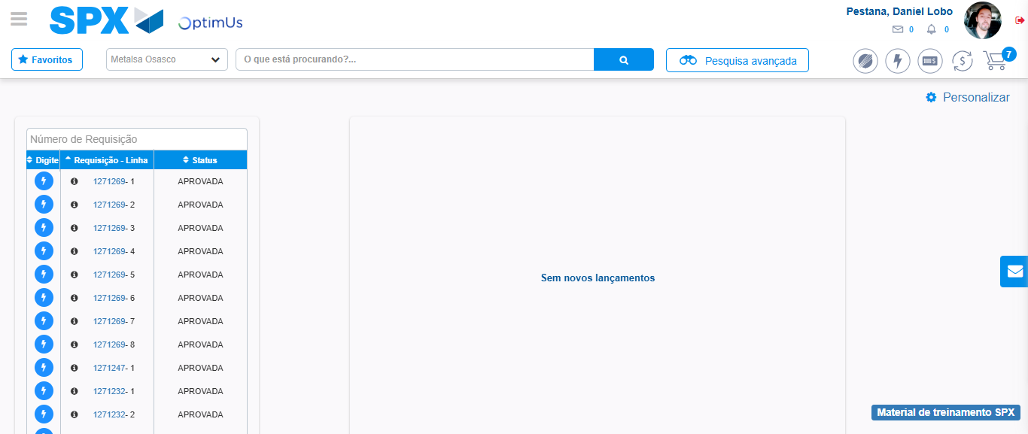Image file-name: QC_Testing-tc006_SPX_Dev5_Crear_Requisicion_Spot_Tipo_Cobro_Proyect_Urgent-1784214671678

Step 8 - Log Out : Log Out SPX
Image file-name: QC_Testing-tc006_SPX_Dev5_Crear_Requisicion_Spot_Tipo_Cobro_Proyect_Urgent-1784214671901

